B&B Club June 2015 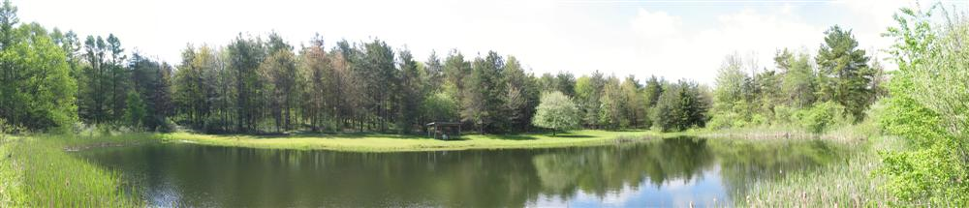
SUNDAY | MONDAY | TUESDAY | WEDNESDAY | THURSDAY | FRIDAY | SATURDAY
Revised 6/29/2015 10:28 AM | 1 | 2 | 3 | 4 | 5 | 6
7 | 8 | 9 | 10 | 11 | 12 | 13  Work Party
14 | 15 | 16 | 17 | 18 | 19 | 20
21 | 22 | 23 | 24 | 25 | 26 | 27  Larry to cut lawn
28 | 29 | 30

B&B Club July 2015
SUNDAY | MONDAY | TUESDAY | WEDNESDAY | THURSDAY | FRIDAY | SATURDAY
Revised 6/29/2015 10:28 AM |  |  | 1 | 2 | 3 | 4  INDEPENDENCE DAY
5 | 6 | 7 | 8 | 9 | 10 | 11  Larry to cut lawn
12 | 13 | 14 | 15 | 16 | 17 | 18  Adam Bickel Lawn Cut
19 | 20 | 21 | 22 | 23 | 24 | 25  Tony Lawn Cut
26 | 27 | 28 | 29 | 30

B&B Club August 2015
SUNDAY | MONDAY | TUESDAY | WEDNESDAY | THURSDAY | FRIDAY | SATURDAY
Revised 6/29/2015 10:28 AM |  |  |  |  |  | 1  Larry to cut lawn
2 | 3 | 4 | 5 | 6 | 7 | 8
9 | 10 | 11 | 12 | 13 | 14 | 15  Joe Huffman Lawn Cut
16 | 17 | 18 | 19 | 20 | 21 | 22
23 | 24 | 25 | 26 | 27 | 28 | 29  Tony Lawn Cut
30 | 31
B&B Club September 2015
SUNDAY | MONDAY | TUESDAY | WEDNESDAY | THURSDAY | FRIDAY | SATURDAY
Revised 6/29/2015 10:28 AM |  | 1 | 2 | 3 | 4 | 5
6 | 7  Labor Day  HOLIDAY | 8 | 9 | 10 | 11 | 12
13 | 14 | 15 | 16 | 17 | 18 | 19  Larry to cut lawn
20 | 21 | 22 | 23 | 24 | 25 | 26
27 | 28 | 29 | 30

B&B Club October 2015
SUNDAY | MONDAY | TUESDAY | WEDNESDAY | THURSDAY | FRIDAY | SATURDAY
Revised 6/29/2015 10:28 AM |  |  |  | 1  Opening Day Bow Season  Final Day apply DMP | 2 | 3  Larry to cut lawn  Opening Weekend Archery
4 | 5 | 6 | 7 | 8 | 9 | 10
11 | 12  Columbus Day  HOLIDAY | 13 | 14 | 15 | 16 | 17
18 | 19 | 20 | 21 | 22 | 23 | 24
25 | 26 | 27 | 28 | 29 | 30 | 31

B&B Club November 2015
SUNDAY | MONDAY | TUESDAY | WEDNESDAY | THURSDAY | FRIDAY | SATURDAY
1  Revised 6/29/2015 10:28 AM | 2 | 3 | 4 | 5 | 6 | 7
8 | 9 | 10 | 11  Veterans Day | 12 | 13 | 14
15 | 16 | 17 | 18 | 19 | 20 | 21  Opening Day Gun Season
22 | 23 | 24 | 25 | 26  Thanksgiving Day | 27 | 28
29 | 30

B&B Club December 2015
SUNDAY | MONDAY | TUESDAY | WEDNESDAY | THURSDAY | FRIDAY | SATURDAY
Revised 6/29/2015 10:28 AM |  | 1 | 2 | 3 | 4 | 5
6 | 7 | 8 | 9 | 10 | 11 | 12
13  Final Day Gun Season | 14 | 15 | 16 | 17 | 18 | 19
20 | 21 | 22  Final Day Late Bow & Muzzleloading | 23 | 24 | 25  Merry Xmas | 26
27 | 28 | 29 | 30 | 31

